**ECE 586**

**COMPUTER ARCHITECTURE**

**TEAM 14**

**Ganeshkumar Sanke**

**Sandeep Reddy Lingala**

For the competition predictor we have used Hybrid predictor.

**Overview:**

The Gshare prediction table is indexed by the XOR result of the PC and the GHR, the Bimodal prediction table is indexed by the PC, and the Select Table prediction table has the same structure as the Bimodal prediction table. When the instruction fetch unit issues an instruction fetch request, the PC will also be generated at the same time. Finally, the prediction results of the Bimodal predictor and the Gshare predictor are selected through the prediction results of the Select table.

**Branch Prediction Algorithm Description:**

In this branch prediction mechanism, three key components are utilized: the Bimodal Predictor, the Gshare Predictor, and the Select Table Predictor. Each component serves a distinct purpose in predicting branch outcomes.

Bimodal Predictor:

* Indexing: The Bimodal Predictor utilizes the Program Counter (PC) as the indexing mechanism. Each entry in the prediction table corresponds to a specific PC.
* Prediction: Based solely on the PC, the Bimodal Predictor predicts whether a branch is likely to be taken or not taken.
* Updation: Based on Branch outcome, it will be updated according to saturating counter.

G share Predictor:

* Indexing: Unlike the Bimodal Predictor, the Gshare Predictor employs the XOR result of the PC and the Global History Register (GHR) as the index for its prediction table.
* Prediction: By combining the PC and the GHR using XOR, the Gshare Predictor offers predictions based on global branch history, potentially enhancing prediction accuracy.
* Updation: Based on Branch outcome, it will be updated according to saturating counter.

Select Table Predictor:

* Structure: The Select Table Predictor shares the same structure as the Bimodal Predictor. Its prediction table is indexed by the PC.
* Functionality: The Select Table Predictor serves as the arbitrator between the predictions generated by the Bimodal and Gshare predictors.
* Selection Process: When an instruction fetch request is initiated, the PC is used to access both the Bimodal and Gshare predictors. Subsequently, the prediction results from these predictors are compared, and the Select Table Predictor determines which prediction to employ for the given branch.
* Updation: Based on Branch outcome, it will be updated according to saturating counter.

**Operation Overview:**

Upon receiving an instruction fetch request, the PC is generated simultaneously. The PC is utilized to access the prediction tables of both the Bimodal and G share predictors. Additionally, the PC, along with the GHR, is subjected to XOR operation to index the G share Predictor's table. Predictions from both the Bimodal and Gshare predictors are obtained. The Select Table Predictor evaluates these predictions and selects the most appropriate one for further processing, thereby facilitating accurate branch prediction. Based on Branch outcome, it will be updated according to saturating counter. This branch prediction mechanism combines both to enhance prediction accuracy, with the Select Table Predictor acting as the decision-maker between the two prediction sources.

**Block Diagram:**

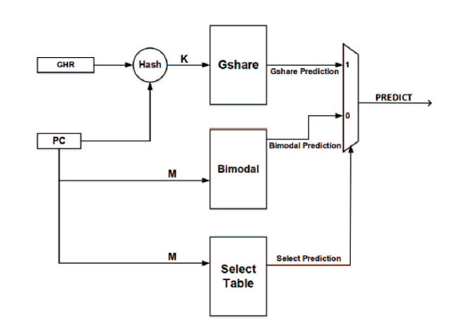

**XOR**

**X**

**Space Budget:**

1. **Hybrid Predictor**

GShare= 8kib x 2 = 16 kib

Bi-modal Predictor= 1kib x 2 = 2 kib

Select predictor= 1 kib x 2 = 2kib

Global Path History(GHR) = 13 bits

Total = 20 kib + 13 bits

= 2.5 kiB + 13 bits

1. **21264 Tournament Branch Predictor**

Global Predictor = 4kib x 2 = 8 kib

Local Predictor= 1kib x 3 = 3 kib

Choice predictor= 4 kib x 2 = 8kib

Local History Table = 1kib x 10= 10 kib

Global Path History = 12 bits

Total = 29 kib + 13 bits

= 3.625 kiB + 12 bits

**Statistics:**

|  |  |  |
| --- | --- | --- |
| Input Trace File | Alpha Predictor | Hybrid Predictor |
| DIST-INT-1 | 7.397 | 8.722 |
| DIST-INT-2 | 9.715 | 9.235 |
| DIST-INT-3 | 12.050 | 14.120 |
| DIST-INT-4 | 2.425 | 2.728 |
| DIST-INT-5 | 0.406 | 0.492 |
| DIST-FP-1 | 3.286 | 4.349 |
| DIST-FP-2 | 1.317 | 1.211 |
| DIST-FP-3 | 0.518 | 0.514 |
| DIST-FP-4 | 0.266 | 0.304 |
| DIST-FP-5 | 1.397 | 1.698 |
| DIST-MM-1 | 8.299 | 8.656 |
| DIST-MM-2 | 10.970 | 10.734 |
| DIST-MM-3 | 2.021 | 5.099 |
| DIST-MM-4 | 2.165 | 2.085 |
| DIST-MM-5 | 6.436 | 6.292 |
| DIST-SERV-1 | 9.853 | 8.819 |
| DIST-SERV-2 | 10.299 | 9.208 |
| DIST-SERV-3 | 7.687 | 7.353 |
| DIST-SERV-4 | 9.492 | 8.276 |
| DIST-SERV-5 | 9.788 | 8.400 |

|  |  |  |
| --- | --- | --- |
|  | Geometric Mean of Alpha | Geometric Mean of Hybrid |
| INT | 3.85 | 4.2 |
| FP | 0.96 | 0.99 |
| MM | 4.8 | 5.7 |
| SERV | 9.3 | 8.3 |
| Overall Geometric Mean | 3.59 | 3.86 |

**References:**

1. <http://ieeexplore.ieee.org/stamp/stamp.jsp?tp=&arnumber=755465&isnumber=16354>
2. [Analysis and Optimization of the Branch Prediction Unit of SweRV EH1 | IEEE Conference Publication | IEEE Xplore](https://ieeexplore.ieee.org/document/9996038)